Data Preprocessing Report
AnalystLab Africa Data Science Internship — Week 2 | Loan Prediction

1. Dataset Overview
The selected dataset is the Loan Prediction Dataset. The training file contains 614 rows and 13 columns, including the target variable Loan_Status. A separate test file was also supplied but was not used for the main preprocessing analysis because it does not contain the target.

2. Data Inspection Findings
The original dataset contained the following missing values:
- Gender: 13 missing values
- Married: 3 missing values
- Dependents: 15 missing values
- Self_Employed: 32 missing values
- LoanAmount: 22 missing values
- Loan_Amount_Term: 14 missing values
- Credit_History: 50 missing values
Duplicate records detected: 0.
The target distribution was 422 approved applications (Y) and 192 non-approved applications (N).

3. Data Cleaning
- Duplicate records were checked and removed where applicable. No duplicates were present in the supplied training data.
- The Dependents category 3+ was standardized to 3 so that the category had a consistent representation.
- Loan_ID was removed because it is an identifier and does not represent an applicant characteristic that should be used as a predictive feature.
- Column names were changed to clear snake_case names for readability and coding consistency.

4. Missing-Value Treatment
Categorical missing values were filled with the mode of the relevant column. Continuous numerical missing values were filled with the median. Median imputation was selected for continuous variables because it is less sensitive to extreme values than mean imputation.

5. Feature Engineering
A new feature named total_income was created by adding applicant_income and coapplicant_income. This provides a combined income measure that can represent the total income available to the loan application. The original income variables were retained because they may contain distinct information about the applicant and coapplicant.

6. Encoding
Categorical variables were prepared using One-Hot Encoding. This method was selected because variables such as education, property area, marital status and employment status represent categories rather than continuous measurements. Credit history and loan amount term were also treated as discrete categories rather than continuous quantities.

7. Feature Scaling
The continuous numerical variables applicant_income, coapplicant_income, loan_amount and total_income were standardized using StandardScaler. Scaling places these variables on a comparable numerical scale and is an appropriate general preprocessing step for machine-learning pipelines.

8. Outlier Detection and Treatment
The IQR method was used to identify extreme values in the continuous numerical variables.
- Applicant Income: 50 observations identified as potential outliers before treatment.
- Coapplicant Income: 18 observations identified as potential outliers before treatment.
- Loan Amount: 41 observations identified as potential outliers before treatment.
- Total Income: 50 observations identified as potential outliers before treatment.
Rather than deleting these observations, IQR capping was applied to continuous monetary variables. Discrete categorical variables were not treated as continuous outliers.

9. Feature Selection and Correlation
The correlation analysis showed a strong relationship between total_income and applicant_income (approximately 0.80), while total_income and loan_amount had a correlation of approximately 0.69. Applicant_income and loan_amount had a correlation of approximately 0.56. These relationships were considered when reviewing potential redundancy.
Random Forest feature importance was also used as a supporting feature-importance analysis. The strongest transformed features included total_income, applicant_income, loan_amount, credit history categories and coapplicant_income.

10. Visualizations
Eight visualizations were produced: loan-status distribution, applicant-income histogram, loan-amount histogram, loan-amount box plot by approval status, education versus approval, credit history versus approval, a numerical correlation heatmap, and a total-income versus loan-amount scatter plot.
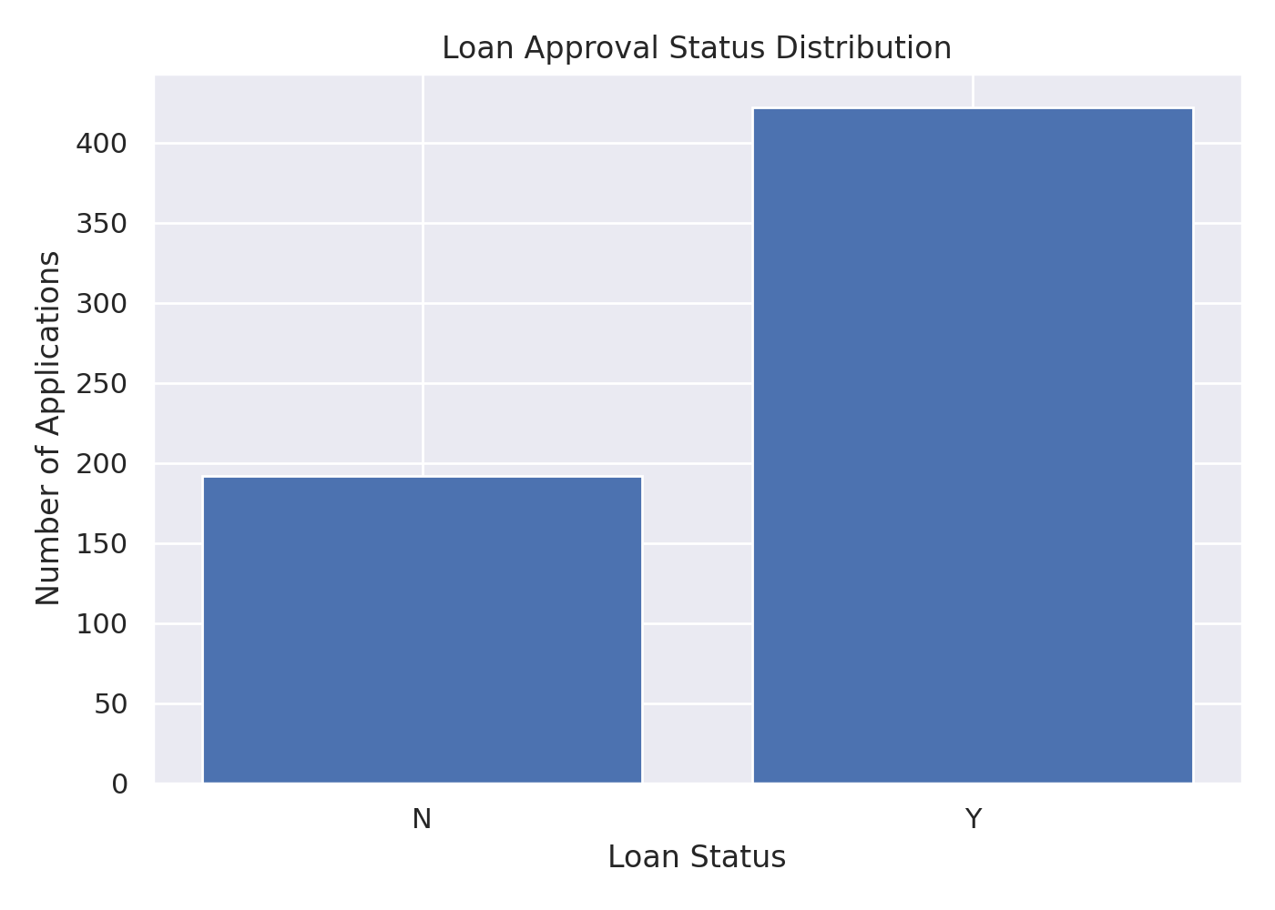
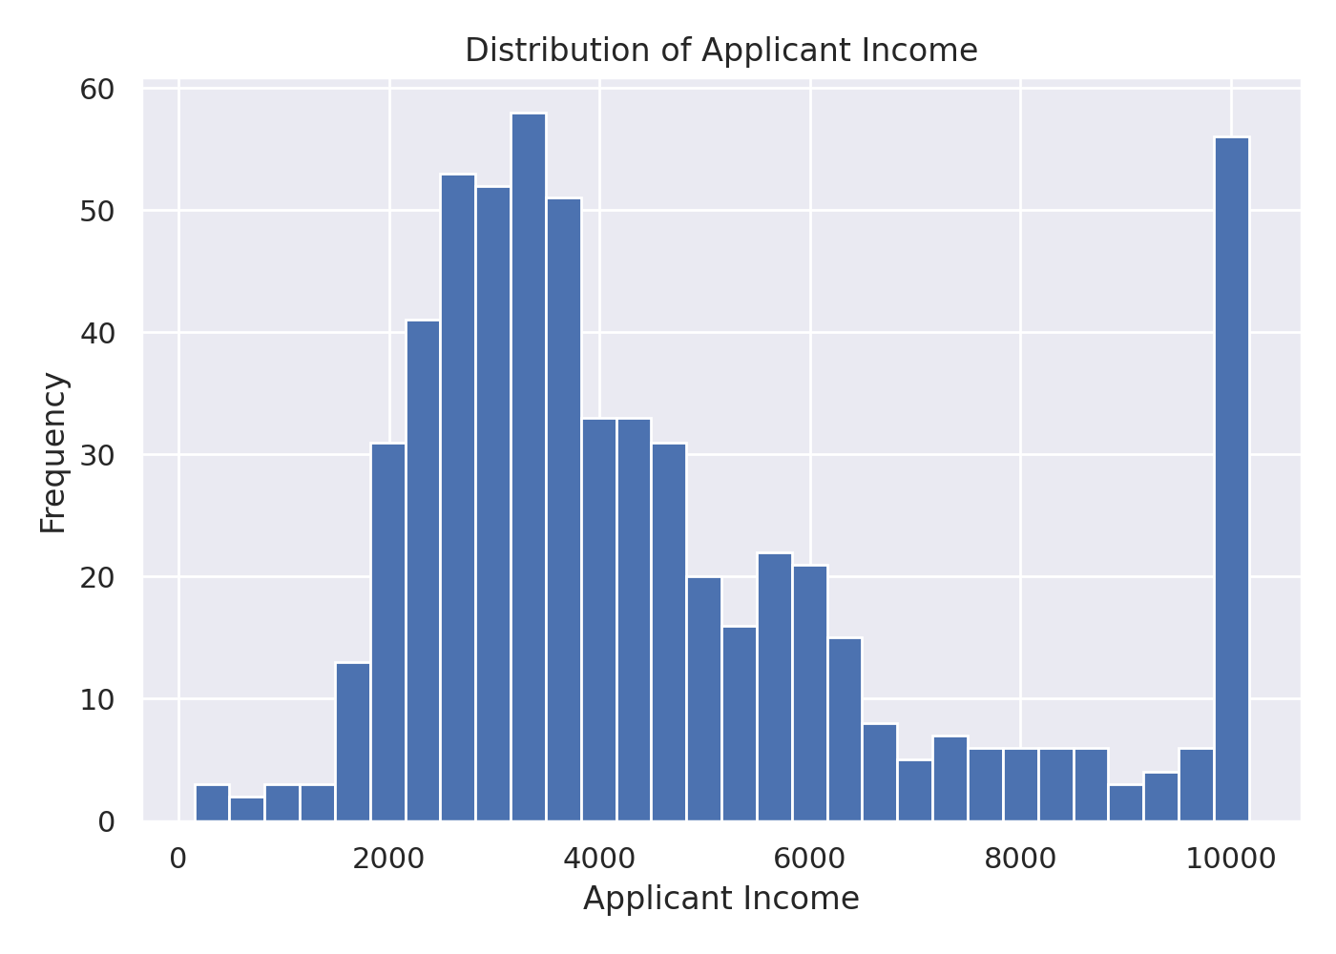
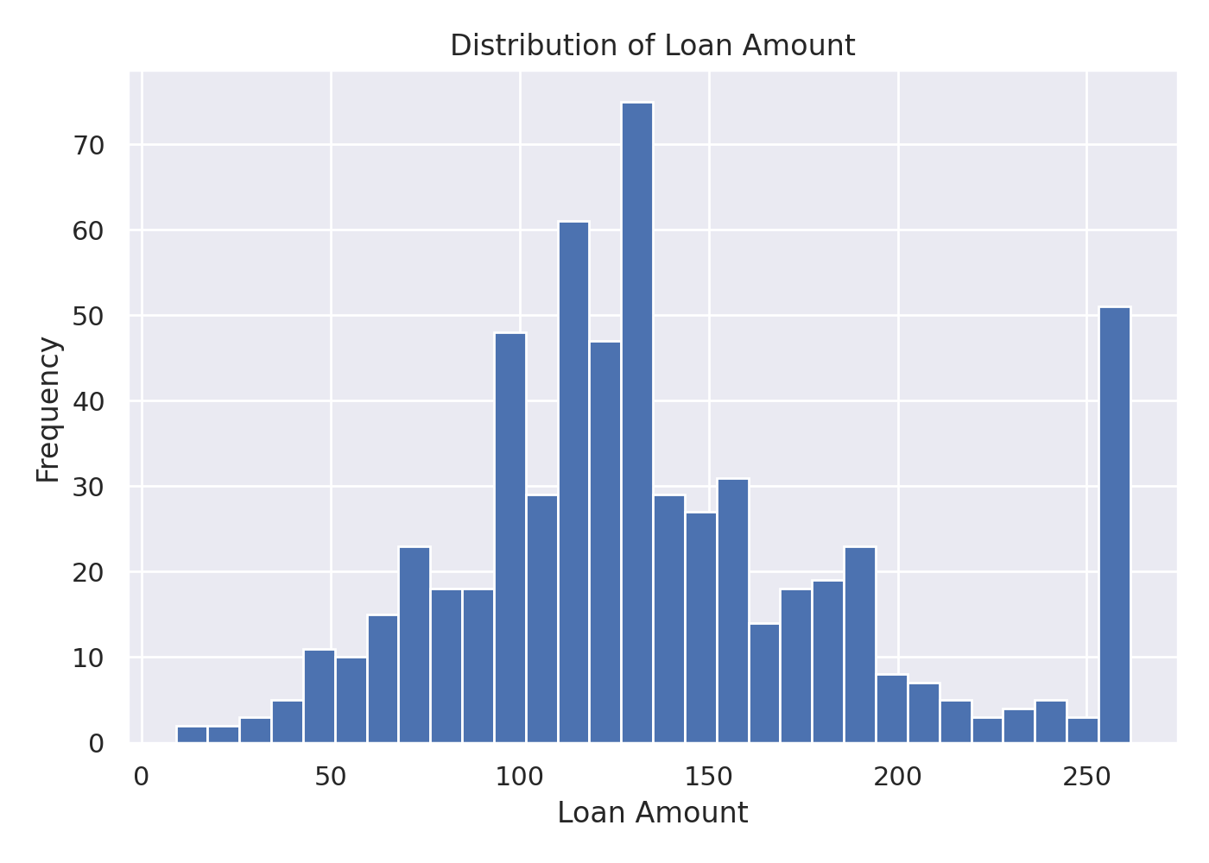
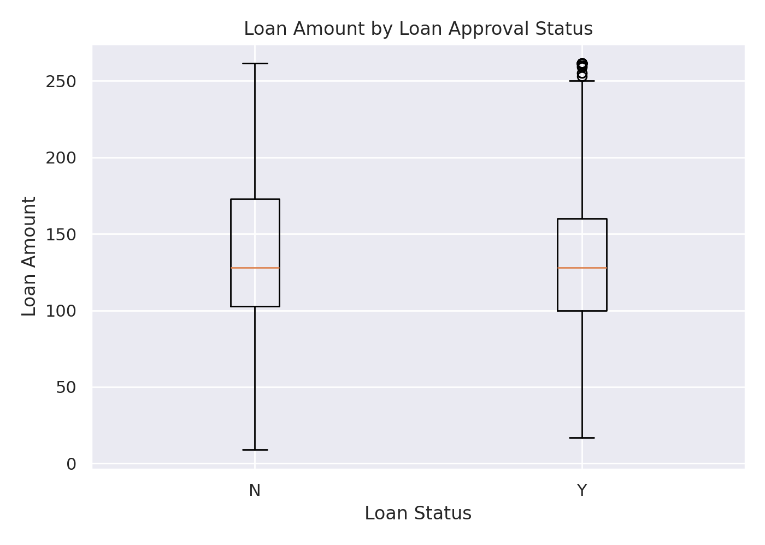
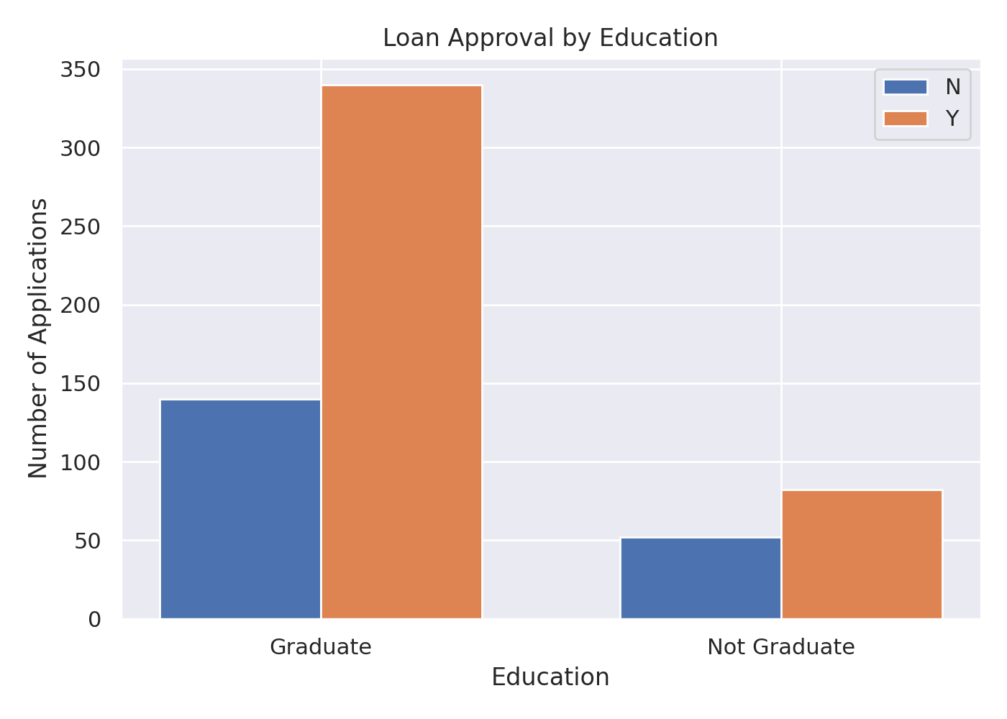
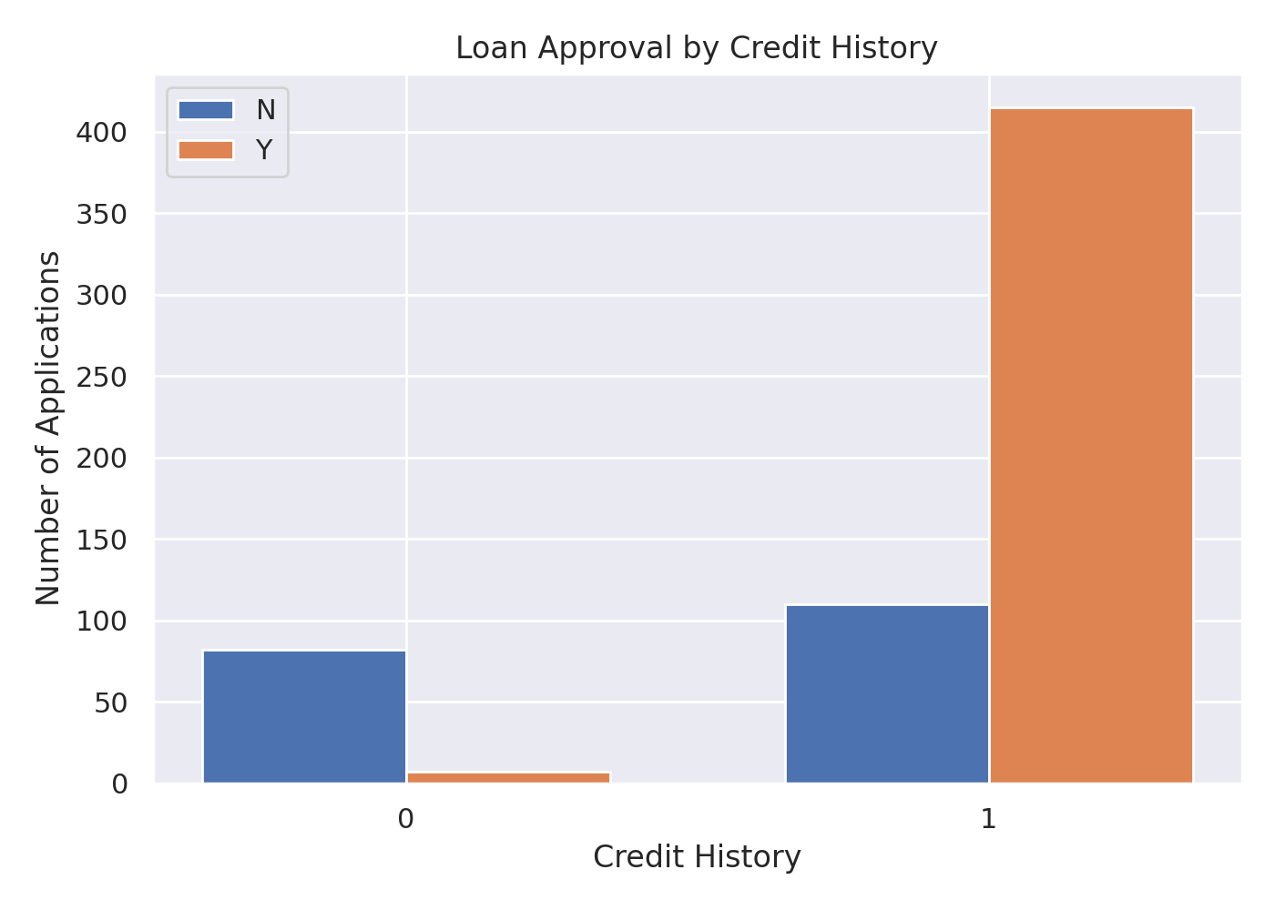
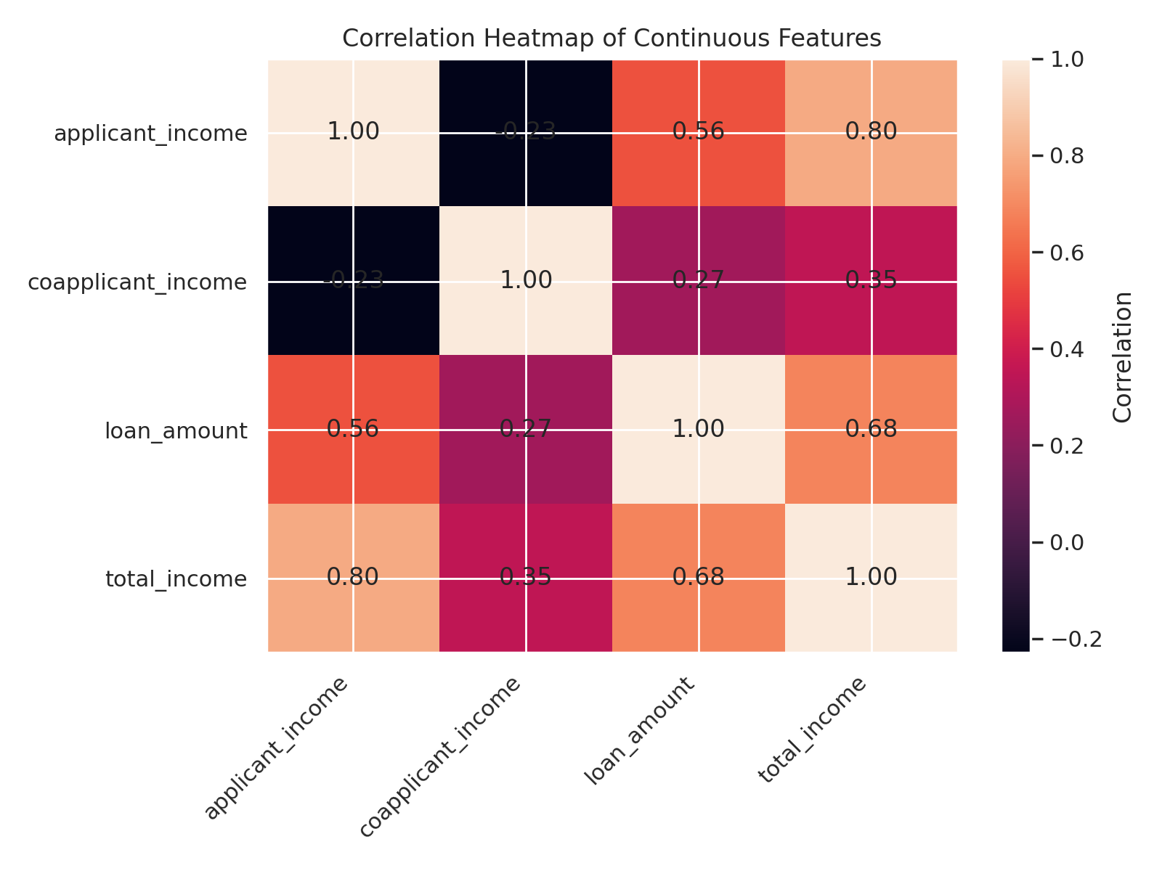
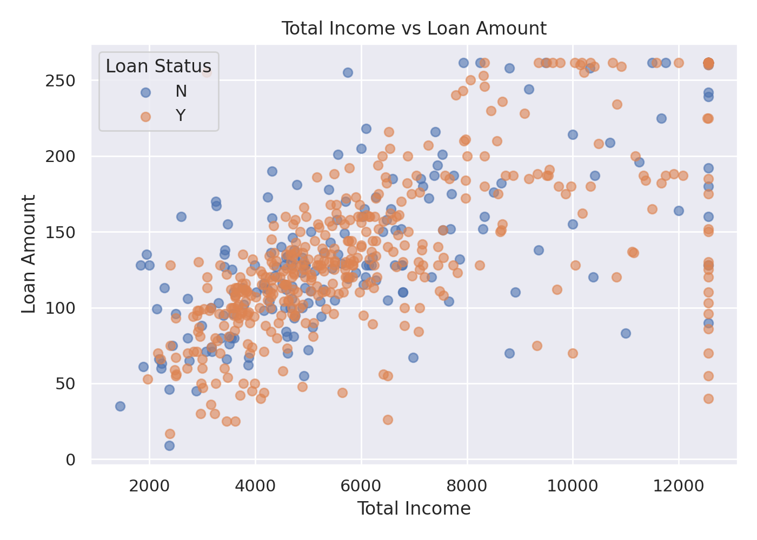

11. Final Machine-Learning Dataset
The final dataset contains the cleaned, engineered, encoded and scaled features together with a numerical loan_status target, where 1 represents Y and 0 represents N. It is suitable as an input dataset for a subsequent classification modelling stage.

12. Conclusion
The preprocessing workflow addresses the Week 2 requirements by assessing missing values and duplicates, correcting representations, engineering a useful total-income feature, encoding categorical variables, scaling continuous variables, detecting and treating outliers, examining correlations and supporting feature selection with feature importance. The resulting data is machine-learning-ready for the next modelling stage.

